Interview

1. Do they use any software solution currently?

No. But they keep the member details in a crude access 2003 tale.

Everything else is booked manually.

2. What kind of information handled/received by staff interactions during work?:

* Induction booking in manual folder
* He also said member data input happens always after actual induction, because it initiates the card access process
* Class booking requests
* Trainer booking requests
* Trainer details
* Resource details (like minivan renting)

3. What data do you record about members?

- FirstName   
- LastName   
- SID   
- MembershipType (Student, Staff, Gym Member, SportsFederation, Gym + SportsFederation, Gym Alumni, Gym Shorterm, Gym SummerSchool, Community Monthly, Community PAYG)   
- Gender   
- Expire Date   
- Renewal (YES, NO)   
- Address   
- Email   
- Phone Number   
- Emergency Number   
- Nationality   
- Receipt Number   
- Money Taken (initials of the person who took the money)   
- Club (if applicable)

4. What data do you record about trainers?

-name  
-Date of birth  
-qualifications (what classes can they do)  
-inductioning (yes/no)  
-personal training (yes/no)

5. What are the gym business hours (when is it open for member access)

8am-10pm

6. What are the shift and lunch times?

- Shifts work from:   
- Early shift: 7:30 till 2:30/3:30   
- Late shift: 1pm till 8pm   
  
Lunch time: 1pm till 1:30pm

Scenario of Current System

Classes run up to 3 times a week

& Machines

10 Classes

Inductions

2 Managers

Customer Payments

200 Members

15 Fitness Instructors

2 Receptionists

Current System

Trees leisure centre & gym is independently run and has no current electronic system for recording time tables, memberships or payment. There is an access database simple containing membership contact details but everything else is recorded by hand and kept on paper. The staff books the inductions manually in an appointment book. There are 2 managers, 2 receptionists and 15 other members of staff, all the contact details and any other information is all stored on paper in the manager office. The gym has fitness machine which can be used by all of gym members, however a member can also book a personal trainer for 2 hour blocks throughout the day. The leisure centre also offers 10 other classes including yoga, spinning class and aerobics, a lot of the classes take place up to 3 times a week to meet the demand of the sym members. Each class can only have a certain number of members; each member can book themselves on a class however a certain number of spaces are always left empty to allow for walk-in’s. If a member wishes to attend any of the classes or book a personal trainer they either phone the reception desk to arrange times or physically visit the gym. At present the record of payment is all on paper and the only information recorded is the initials of receiving staff.

The trainers are employed specifically for the time constraints of the classes, therefore the system needs not to care about individual trainer availability as they sort out between each, if there is more than one trainer for a class.

Currently there are no access rights at all, anyone can start up the access database and modify any data or write anything into the manual records. We also propose at least three user access level: manager, staff and customer (for booking class over internet).

**Rich Picture**

Database

Servers

Networking

Online system

Class Booking

Timetabling

Rotas

Back office systems

Log in/log out

Terminals

Implementation

Maintenance

Training

Machinery/equipment

Facilities

Classes available

Class users

Casual gym users

Regular gym users

Software

Existing Features

Market

Cost

Hardware

**Gym Management System**

Use Case

Amend Class List

Amend Staff List

Manager

Amend Room List

Amend Booking

Amend Member List

Issue New Card

Renew Membership

Receptionist/

Fitness Instructor

Send Feedback

Amend Details

Member

Book Class

View Progress

Proposed System

The proposed system will be able to hold the staff rotas, which will be set and edited by the manager and viewed by the members of staff. The manager will also be able to add new classes to the system for example if the gym decided to start teaching a spin class then the information about the class would need to be added to the system so that members could be booked on that particular class. The program also needs to be able to book members on class induction and/or personal training session. There needs to be a facility that can record information about new members, and then record the member’s progress throughout their membership. For example it would include classes they have attended and target weight.

There needs to be access rights implemented within the gym to make sure that the system is secure and that all information is kept safe. Different security levels can be controlled by giving certain user names access to only certain areas of the system. For example fitness instructors can only view staff rotas, enrol members on a class, view class information, view member information and alter member information, where as the manager can do all of this and have the added privileges of editing staff information, staff rotas, class information and adding brand new classes to the system.

This will be implemented on to two computers situated at the front desk, for use by the receptionist and the fitness instructors. There will also be a computer in the manager’s office so that they can do work in private.

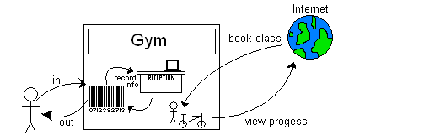

Gantt chart

We have constructed two gantt charts, one of these gantt charts has been constructed One of these gantt charts was constructed in Microsoft project that particular gantt chart shows just the stages of the entire process from the start of the requirement analysis until the project has been completed and implemented. However it does to specify tasks it is just a top level plan.

The other however was constructed using a piece of project management software called ‘dot project’, we have chosen this software because it is accessed online and can be accessed and edited by any member of the group. Each task is given a start and end date, it is also required that a member the group to be assigned to completing the task, more than one member can be assigned to a task. This means that if a new task is decided then any member can log on and assign themselves to that task. It keeps the plan up to date and allows any member of the group to check the time or place of a meeting. Dot Project also has the capability to upload documents and share them with each member of the group, a member can edit that document and upload a new version. This means that we can study any changes to make sure we don’t lose any important information.

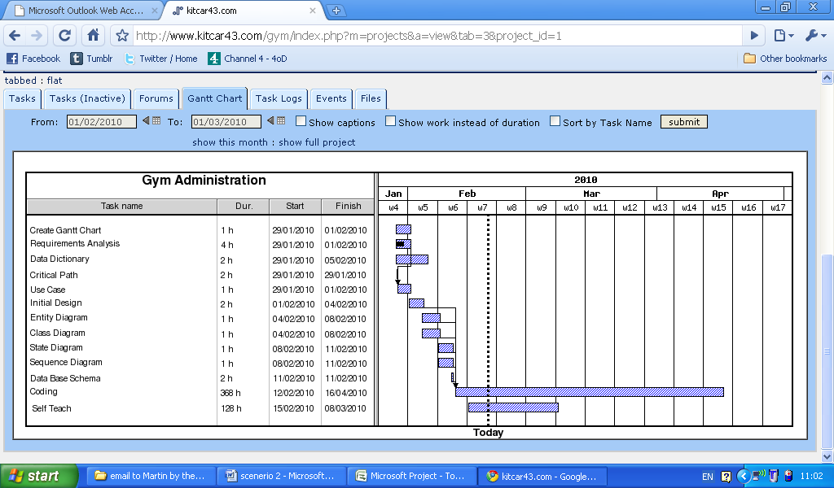 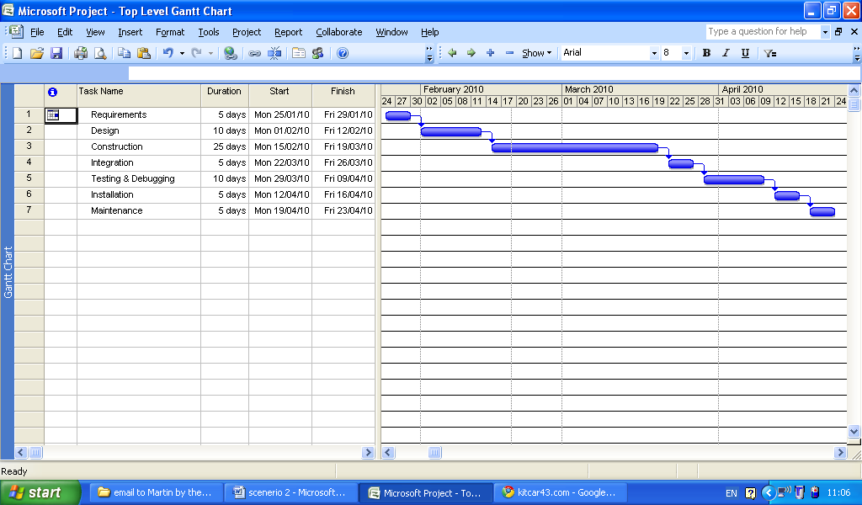

**NOTES**

Microsoft Project

Microsoft Project is a project management software program it is designed to assist project managers. The program allows you to track project progress, budgets, resources, developments and analyzing workloads.

The program also allows you to create critical path schedules from the information that is entered. There is also user options so that different classes of users can be defined to control different access levels.

Resources can easily be assigned to different tasks to make sure that deadlines are met & all users are aware of what needs to be done. Finances can easily be controlled which can improve cost estimates.

Gantt Chart

A gantt chart illustrates a project schedule, it shows the start and end dates of the terminal elements and summary elements of a project. Some gantt charts also show dependencies between tasks. For example of the project was to build a house, the roof couldn’t be started until the walls were excited. Different shading and labels illustrate the urgency ad completion levels of the project and its tasks.

Critical Path

The critical path method or critical path analysis is a mathematically based algorithm for scheduling a set of project activities. It is an important tool for effective project management.

The technique for CPM includes the following:

1. A list of all activities required to complete the project
2. The time that each activity will take to complete.
3. The dependencies between the activities.

Using these values CPM calculates the longest path of the planned tasks from start to finish. It also includes the start and finish times for each task what extending the length of the project. The process determines which tasks are critical and which tasks can be delayed.

The result of the critical path analysis allows managers to practice tasks to make sure that the completion of the task is time effective and target met.

The expected system should incorporate a booking system. In the current system only one class is book by the gym staff. We recommend for the system to allow multiple booking for multiple classes.

however the system still has to be able to keep track of which trainer does what on a rota basis.

There is no record of trainer qualification but the system has to be able to provide option to allocate the right trainer to the right course.